Math/Stat 170 Lab Project 5

Macros

The purpose of this lab is to introduce you to additional functionality with in Excel. In particular, you will be introduced to Macros and the graphing functionality. A Macro is a program in Excel that allows you to execute several steps at a time.

This project builds on Lab 4. In Part 2 of Lab 4, we computed the minimum premium for a 30 year term insurance policy with a death benefit of $10,000 issued to a male age 61 assuming a rate of return of 10% on investments. In Part 1 of this lab, you will record a “Macro” which changes the output to compute the premium for a 40 year old male insured. In Part 2, you will modify the Macro from Part 1 to allow you to input the age of the insured into an “InputBox” causing Excel to automatically compute the premium. In Part 3, you will use Excel to make a bar graph of the premium as a function of age for a particular age group and a particular interest rate.

Part 1:

- Save a copy of the output from Lab 4 into a file called Lastname_Firstname_lab5.xls. Then open this file. (See the first screen shot below.) The remaining directions refer to the cell numbering in this figure.
- We will want to be able to change the age of the customer. If not already set up, change cell B17 to “=I8” and B18 to “=B17+1”. Then copy this formula all the way down the page.
- Go to Sheet2 and Sheet3 and delete all information from those sheets.
- Copy the mortality table MorTab.xls onto Sheet3 of your workbook. You may need to insert an additional worksheet by right clicking a tab and selecting “Insert…, Worksheet”. You can change the name of the sheet be right clicking on the corresponding tab for the sheet and selecting "Rename" from the menu. You can change the ordering of the sheets by dragging the tabs. Rename the sheet to be MortTab.
- Next we will make use of the “Record Macro” feature of Excel. When turned on, it acts like a tape recorder, recording, step-by-step, every action you do until you turn it off. When set on “Run” it will redo all of your steps, exactly as you did them. Specifically, you will turn on the recorder, modify your spread sheet to compute the premium for a person at age 40, and then turn off the recorder. Explicitly, do the following:
- Select “View--Macros--Record Macro...” You will see a box prompting you to name the Macro. Name it something like “AgeChange”. Then click on O.K. The recording has begun. (See the second screen shot below.)
- Next, go through all of the steps to compute the premium for a 30 year term policy for 40 year old male. This will involve: (a) changing the age in cell H9; (b) Going to MortTab sheet and copying ages 40 to 69 from the “male” column of the Mortality table into your table; and (c) running “Goal Seek” to find the premium.
- Now turn off the recording of the Macro by selecting “View--Macros - -StopRecording.”
- Test your macro by selecting “View--Macros –View Macros.” In the box, highlight the macro name (if it isn’t already highlighted) and choose “Run.” You should see a complete replay of all of the steps you just did.

Part 2

What you just did in Part 1, as it stands, is pretty worthless because it only computes the premium for a 40 year old. But we can change this. Select “View--Macro--View Macros” highlight the macro name (if it isn’t already highlighted) and choose “Edit.” You should see something like what is shown on Page 3 in a new window. What you are looking at is a computer program in the language “Visual Basic for Applications” which is the programming language of most Microsoft products such as Excel, Word, Power Point, etc. This program was generated by the “Record Macro” option.

The italicized statements are the ones that we need to change to compute the premium. Replace the line

ActiveCell.FormulaR1C1 = "40"

with the following two lines:

Age=InputBox(“Age of Customer”)
ActiveCell.FormulaR1C1 = Age
Range(“I9”).Select
Gender = ActiveCell.FormulaR1C1

Replace the line

Range("C49:C78").Select

with the lines

If Gender = "Male" Then
First = "C" & (Age + 9)
Last = "C" & (Age + 9 + 29)
ElseIf Gender = "Female" Then
First = "B" & (Age + 9)
Last = "B" & (Age + 9 + 29)
End If
Range(First, Last).Select

Your final result should appear as in the third screen shot.

When you have finished making these changes, select "File-Close and Return to Microsoft Excel"

Remark: Visual Basic has several “types” of variables. One type is “integer” such as 29. Another is “string” which is just a bunch of symbols, such as C49, strung together. Putting quotation marks around a sequence of letters lets Excel know that it is a string variable. Thus “49” is not a number but rather is the symbol formed by writing a 4 next to a 9. The symbol & (concatenation) joins strings together. Thus, if Age=40, then First=“C”&(Age+9) produces the string C49 which is the first cell in our range. One might expect that First=“C”&(Age+9) would produce an error since, in our program, Age is an integer variable and C is a string variable. However, Excel is smart enough to automatically interpret Age as a string when this is the only way the expression could have meaning.

Part 3 In your individualized data, you are given the Age and sex of the insured as well as an interest rate. Use your macro to compute the premium for Age+5n where n=0, 1, 2, 3, 4, 5 for the stated interest rate. Thus, if Age=40, you will compute the premium for age 40, 45, 50, 55, 60, and 65. Record these values on paper. Title Sheet2 of the output “Premium by Age.” Then, by hand, in two appropriately labeled columns, enter the age and premium data just computed. (See fifth screen shot.) Highlight the premium data and click “Insert--Other Charts--All Chart Types…” Choose a chart type and click OK. Insert another tab (right click, Insert…, Chart), and cut and paste your chart into this tab. My chart is in the fifth screen shot. You can choose a different chart if you like. Make sure that all axes have labels in order to receive full credit (like in the picture).

Extra Credit: Create a second Macro that (a) automatically generates Sheet2, using the Age in Cell H8 as the starting point and (b) automatically generates the Bar graph. You will want to begin by recording a Macro that (a) runs the Macro from Part 2 and (b) records the outputs in the appropriate cells in Sheet2. You will modify this Macro to produce all of Sheet2. (You might want to read about For statements in Visual Basic Online Help.) You can then record a third Macro that runs the one just created and then constructs the graph.

Warning: Save a copy of the completed project before messing around with it.

Upload the completed project to Blackboard prior to the deadline indicated in Blackboard following the instructions in the “Instructions for submitting labs” found on the course web page.

Picture 1
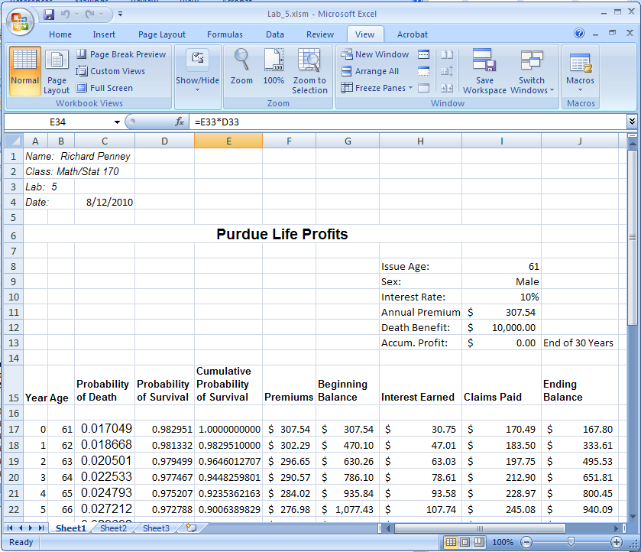

Picture 2
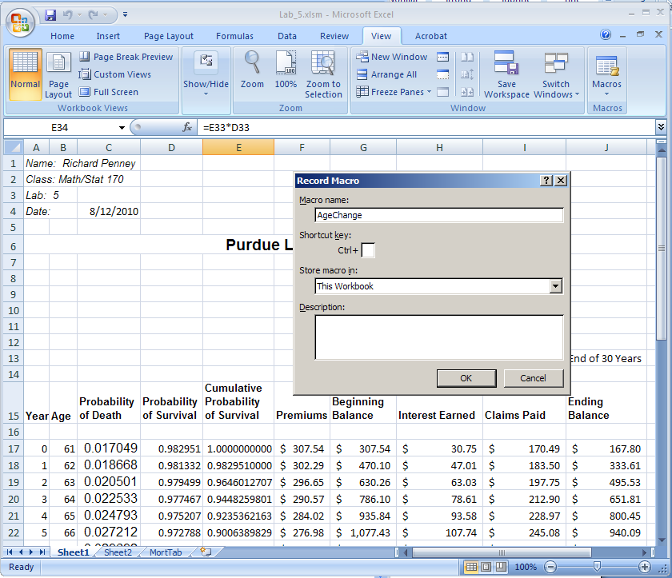

Picture 3
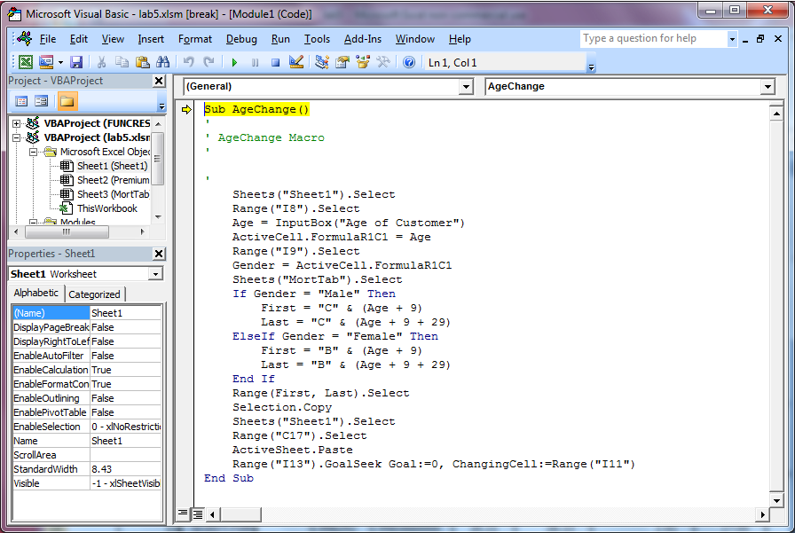

Picture 4
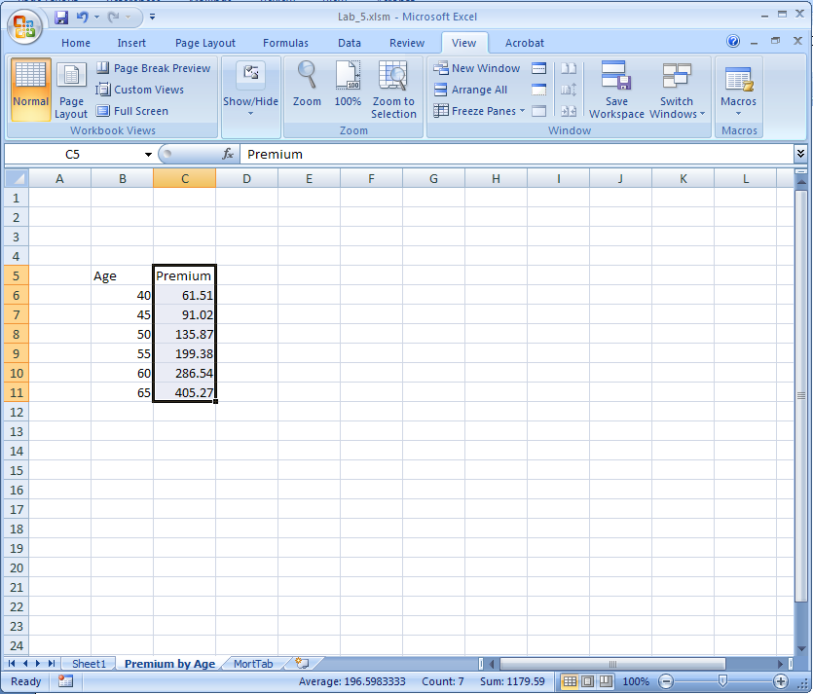

Picture 5
